# **Exercise 2 Rules and constraints**

1. What do we mean by a Turing test? Explain how such a test should be conducted.
2. What 3 main features characterises an agent? Make a simple drawing of a conceptual agent and how it interacts with the environment? Name three types of agents.
3. The graph structure is ideal for general state space representation. Explain why and define the individual components of such a graph.
4. Check the expression below:

*P( Rain ∩ Dark clouds)*

*P(Rain | Dark clouds ) = P(Dark clouds )*

Explain what is stated here.

Assume that you know how many days a year dark clouds appear. If you have statistics for rain observed in a region and you know how often dark clouds can be observed given that it rains explain how you can determine P(Rain | Dark clouds ).? Describe what you need to do in a stepwise manner.

1. Below you have a rule base of four rules in an expert system:
2. IF Battery becomes flat

THEN Car will not start

1. IF Headlights are on

AND Engine is off for a long time

THEN Battery becomes flat

1. IF Car is out of petrol

THEN Car will not start

1. IF Switch is not turned to off

and Alarm does not sound when you leave the car

THEN Headlights are on

Demonstrate backward and forward chaining with these rules.

1. Below you see two fuzzy sets describing a collective opinion about Chilly and Warm. Assume that you have a controller with two rules:

* IF Chilly THEN Heat
* IF Warm THEN Cool

By means of the Sugeno method the support values for Heat and Cool are 2000W and 200W respectively. If the temperature is 19C determine the output from the heater that the controller manages.

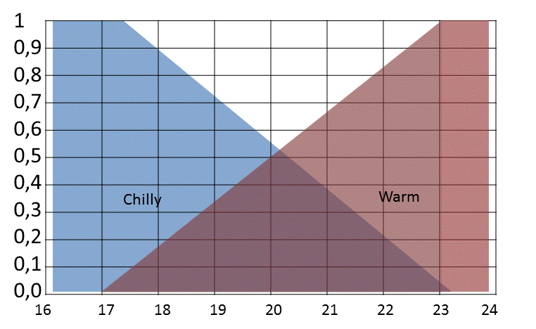

1. A game

In a game there exists a planet where several kings rule. Each king controls his own state. Some of the kings are lethal enemies. Others enjoy very friendly relationships. But this may change. Your avatar is a software agent and represents a galactic empire. He has just become the governor of this planet. His task is to make the planet prosper. Therefore peace must prevail. If he is successful he will be elected to the senate of the empire and be rewarded handsomely. The following states and boundaries can be found on the planet.

* Nadra
* Conadra
* Filafong
* Sunepa
* Kiala
* Cronos
* Peturum
* Watcha
* Xeloxelo

In order to avoid that the states wage war against each other your avatar must deploy neutral imperial troops. The problem is that the agent cannot spare that many men to this task. However, the power balance can still be established even if the imperial troops are not evenly distributed across all states. If the imperial troops are assigned to a state, then the governor does not need to deploy any in the neighboring states. As an alternative to troops ambassadors representing the imperial authorities can be instructed to move to a state. They can monitor the state of affairs and notify the governor in time for him to rally troops to potential trouble spots. It is a cheaper alternative than troops. The only problem is that the governor has only 4 ambassadors that he can really trust. The governor is not obliged to assign ambassadors to states that already are controlled by his troops. If a kingdom has been assigned an imperial ambassador the neighboring states will not have any. There must be no instance where two neighboring states have neither an ambassador nor troops.

1. Construct a Constraint Graf for the planet with all the states included.
2. Show how a constraint propagation algorithm (AC1) can help the governor to deploy his troops to fulfill the goals that he has defined in order to maintain peace. Describe what the computer should do to solve this problem, step-by-step.
3. Specify what states will have ambassadors and which one will have troops. What are the minimum troops that need to be deployed given by the algorithm? Can the algorithm guarantee an optimal solution? Explain briefly.